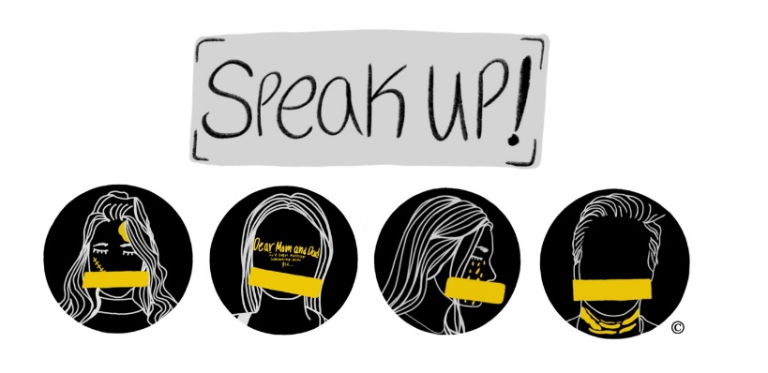

SPEAK UP! CAST AUDITION APPLICATION SPEAK UP! 2021-2022
SPEAK UP! is an original, award-winning play written and performed by Santa Margarita Catholic High School students that gives voice to some of the most troubling and traumatic issues facing young people today. The often taboo topics of identity, sexual assault, harassment and suicide are brought to the stage in a powerful 25-minute performance that serves as a catalyst for conversation afterward. SPEAK UP! seeks to educate and empower young people and to equip adults with the tools they need to listen and support them. SPEAK UP! is a call to action.
Auditions will be held for the 25 minute play SPEAK UP! on Tuesday August 31 at 2:30 p.m. in the Black Box for the roles of Catherine and Gwen. Members of the class of 2022 and 2023 are eligible to audition. Auditions script sides will be available for cold reading.
NAME:_____________________________________________ GRADUATION YEAR: ________
I have seen the play: YES _____ NO _____
My parent has seen the play: YES _____ NO _____
I have discussed the content of the play with my parents. YES _____ NO _____
I participated in the small group discussions in Sophomore Religion . YES ____ NO_____
I would like to interview and audition for a role in SPEAK UP! _______
I understand that if cast, I am making a commitment to all rehearsals for the play. _____
I understand that if I am cast, I am making a year-long commitment to Project SPEAK UP! which may require travel and missing school. ______
If cast, I understand that I am required to attend SPEAK UP! Ambassador Training on Sept. 27 _____
I understand that performances for 2021 will be on November 3, 5, and 12 _____
I have attached a one-page statement explaining why I would like to be cast in the play, SPEAK UP!
Student Signature: _____________________________________ Date:_________________

Parent Signature:______________________________________ Date:__________________

